Calculus (4): Differentiation of Trigonometrical Functions
In this Chapter we extend our technique of differentiation to include the trigonometrical functions. We begin by finding a very important limit which is required later:
lim 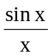.
x → 0
Look at the sine table in your book of tables, where the angle is small and compare the value of sin x with x (expressed in radians).
Angle x |  | sin x  1.1736  0.0872  0.0523  0.0175  0.0087  0.0017  0.0009
in degrees | in radians
10  5  3  1  30'  6'  3' | 0.1745  0.0873  0.0524  0.0175  0.00873  0.00175  0.0009

Clearly when x is small, say less than 5º , sin x ≈ x or 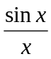 ≈ 1 provided x is in radians. It is impossible to make any more precise comparison using 4 figure tables, but it would seem reasonable to predict that lim = 1, x → 0
provided we work in radian measure.
Here is a simple proof of this result.
In fig 16.1 OAB is a sector of a circle radius r, AOB (acute) = θ radians, AB is a chord and AC is the tangent at A.
AC = r tan θ.
Then ∆AOB < area of sector OAB < ∆OAC.
i.e., r² sin θ < r² θ < r² tan θ
hence 1 < 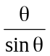 < 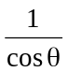.
Now as θ → 0, cos θ → 1 and 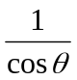 also → 1.
C
O
A
r
r
B
θ
Fig 16.1
The left hand term of the inequality is fixed at I and the right hand term decreases and tends to 1, as θ → 0, and the middle term must also tend to 1.
Hence lim = 1 and reverting to x as the variable
θ → 0
lim = 1 where x is in rad.
θ → 0

This result plays a crucial part in finding the derivative of sin x. To take advantage of it, we must work in radians throughout.

Derivative of sin x
Working as before from first principles (Chapter 9) let y = sin x, x is in radians. Take an increment δx in x to produce a corresponding increment δy in y.
Then y + δy = sin (x + δx).
Hence δy = sin (x + δx) – sin x
= 2cos(x + δx) sin(δx)
using one of the factor formulae.
Therefore 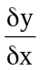 = 2cos(x + 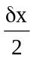)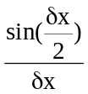
= cos(x + )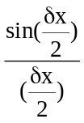.
Now as δx → 0, → ,
cos (x + ) → cos x
and using the above limit,
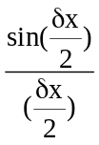→ 1.
Hence = cos x.
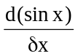 = cos x whre x is in rad.
The gradient at any point on the sine curve (y = sin x) is the value of cos x for that value of x. A comparison of the two curves (fig 16.2) illustrates this.
Composite functions involving the sine can now be differentiated.
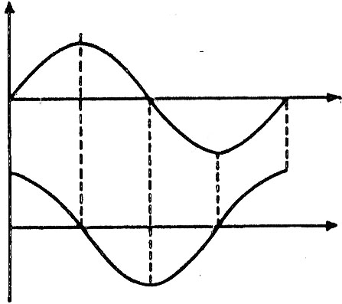
y
x
Fig 16.2
y = sin x
x
Example 1
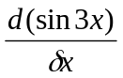 = cos 3x x 3.
First differentiate sin … wrt (3x) and then differentiate 3x wrt x.
So, if y = sin(2x + 5),
= [cos(2x + 5)] x 2
= 2 cos(2x + 5).
Again, if y = sin² 3x, = 2 sin3x x cos3x x 3
Differentiate differentiate differentiate
sin²3x as a sin3x wrt 3x 3x wrt x
power wrt
sin3x
= 6 sin3x cos3x
= 3 sin6x.
Example 2
y = sin xº. Find .
We must first convert the angle to radians.
xº = 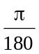 x radians.
Hence y = sin xº = sin 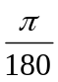 x.
Then = cos x = cos xº.

Derivative of cos x
Since cos x = sin(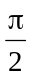- x),
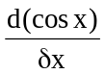 = cos( - x)x(-1)
= - cos(- x)
= - sin x.
Alternatively we can work again from first principles.
Let y = cos x, x is in radians, then y + δy = cos (x + δx) taking as before increments δx and δy.
Then δy = cos (x + δx) – cos x
= - 2 sin (x + δx) sin(δx).
Therefore = - 2 sin(x + δx)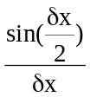
= - sin (x + δx)
And hence in the limit, when δx → 0, = - sinx.
= sin x where x is in rad.

Example 3
If y = cos 5x, = - sin 5x x 5 = - 5 sin 5x.
If y = cos² (2x – 3), = 2 cos (2x – 3) x [ - sin (2x – 3)] x 2
= - 4 cos (2x – 3) sin (2x – 3)
= - 2 sin 2 (2x – 3).
The methods previously used for differentiating products, quotients, and for finding maximum and minimum values can also be applied where necessary.

Derivative of tan x

Example 4
Find the derivative of tan x.
If y = tan x = 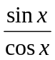, then by the quotient rule,
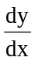 = 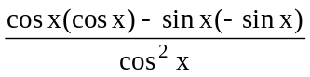
= 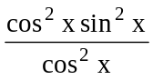
= 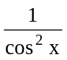.
Hence 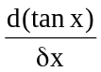 = sec² x where x is in rad.

Example 5
If y = (1 + x²) sin 2x, find and its value when x = .
By the product rule,
= (1 + x²) 2 cos 2x + (2x) sin 2x.
When x = , = (1 + 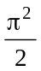)2 cos (2 x ) + (2 x ) sin (2 x )
= -2(1 + ) as cos π = - 1 and sin π = 0.

Example 6
If xy = sin 2x, prove that x 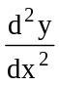 + 2 + 4xy = 0.
Differentiate wrt x, treating xy as a product:
x + y = 2cos2x.
Now differentiate again wrt x, treating x as a product:
x + + = - 2 sin2x x 2
= - 4sin2x
= - 4xy
Hence + 2 + 4xy = 0.

Example 7
Differentiate tan³ 2x.
If y = tan³2x,
= 3 tan²2x x sec²2x x 2
= 6 tan²2x sec²2x.
(tan³ … is first differentiated as a power, then tan … is differentiated, and finally 2x is differentiated).

Example 8
Find the maximum and minimum value of 3 sin x + 4 cos x and the values of x at which they occur.
Take y = 3sin x + 4cos x.
= 3cos x – 4sin x
and = 0 at the turning points.
If = 0, then 3cosx – 4sin x = 0 or tanx = .
In the range 0º – 360º this gives x = 36º 52′ or 216º 52′.
Our usual test to distinguish between the maximum and minimum values is a little awkward in this case, but we can ease the working if we modify the expression for .
= 3cos x – 4sinx
= cosx (3 – 4 tanx)
= 4cosx ( - tanx). (see table below)
x
5
3
4
Fig 16.3
When tan x = , sin x = and cos x = (x in the first quadrant)
(fig 16.3) or sin x = 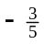, cosx = 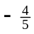 (x in the third quadrant). Therefore the maximum value of y when x = 36º 52′ is 3() + 4() = and the minimum value of y when x = 216º 52′ is -5. (These values will recur every 360º).
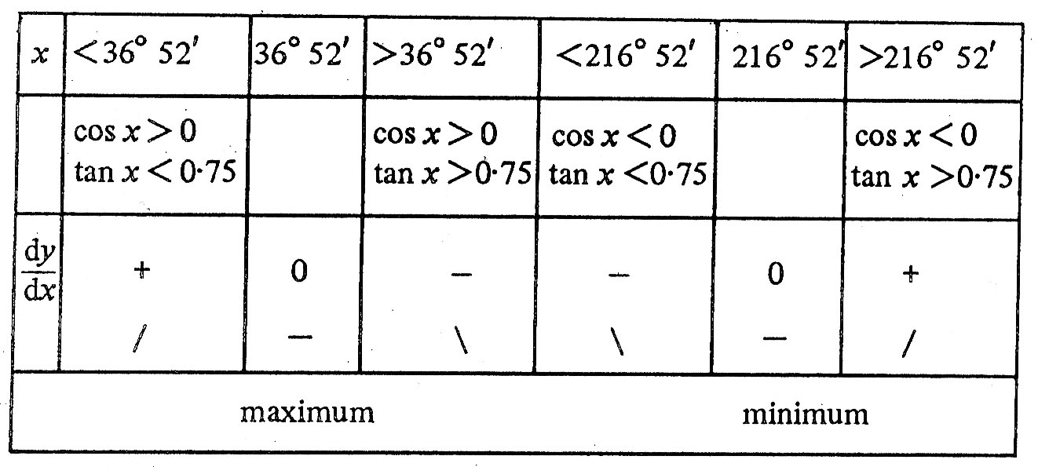

Example

If y = x³ + cos x –In + 4
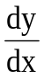 = 3x²-sin x-

If y = 7x⁴
= 7(4x³)
= 28x³
Example
y = xe^{x}
let u = x and v = e^{x}
Then 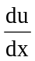=1 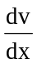=e^{x}
Using = v +u
= e^{x}.1+x.e^{x}
= e^{x}(1+x)
Example

(a) (2x³ – 1) sin x
(b) 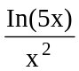.

(a) Let y = (2x³ -1) sin x, a product,
So let u = 2x³ – 1 and v = sin x.
Now 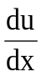= 6x² and 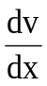 = cos x,
Using 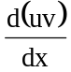 = 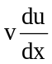 + 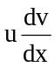,
= sin x. 6x² + (2x³ – 1).cos x
= 2x³ cos x + 6x² sin x – cos x.

(b) Let y = 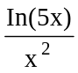, a quotient,
So let u = In (5x) and v =x²
Now = 5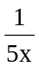 and = 2x
Using 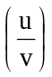 = 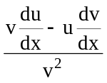
= 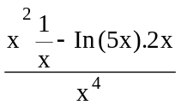
= 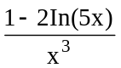
Example
A curve has equation y = sin⁻¹ x. Find 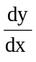.
y = sin-1 x ⇒ x = sin y.
So, 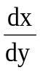= cos y = 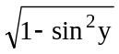 = 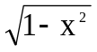.
Hence , 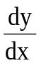=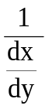 = 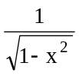.
Example
Given y = secx, find
Y = secx = 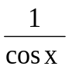
Using the quotient rule (see P20),
= 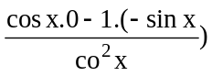
= 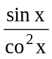
= 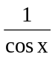tan x
= sec x tan x.
Example
If y = x⁶ + 4x² - 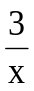
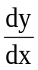 = 6x⁵ + 8x + 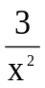 first derivative
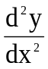 = 30x⁴ + 8 - 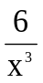 second derivative
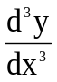 = 120x³ + 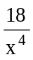 third derivative

Standard results
Algebraic
function | derivative
constant | 0  nx^{n-1}
sin x  cos x  tan x | cos x  -sin x  sec² x

Trigonometrically
(x in radians)
function | derivative
In x  e^{x} | 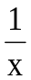  e^{x}

function | derivative
cosec x  sec x  cot x | -cosec x cot x  sec x tan x  - cosec²x
sin⁻¹ x  cos⁻¹ x  tan⁻¹ x | 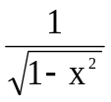  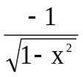  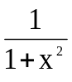

Exercise 16
Differentiate wrt x (x in radians):
1. sec x [take as (cos x)⁻¹ ]2. cosecx 3. cotx
4. sin 4x 5. cos 6x 6. tan2x 7. cot3x
8. cos(2x – 8) 9. sin(3x + 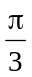) 10. xtan x
11. xcos2x 12. xsin3x 13. cos2x + sin x
14. sin x – cos x 15. cos² x 16. sin² 5x
17. tan² x 18. sin² (x - 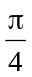) 19. 4x² + sin4x
20. 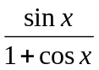 21. 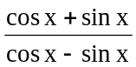 22. 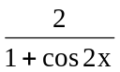
23. sinx tan x 24. sec²x 25. tan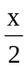 26. x²tan x
27. (1 + x²)tan x 28. 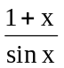 29. 2cos²x – sin²x
30. (1 + sin x)(1 – cosx)
31. If y = sin 2x, find , , 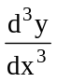.
32. Find the maximum and minimum values of 2 cosx + sin x and the values of x at which they occur (in the range 0º to 360º).
33. If x cosy = sin x, prove that = 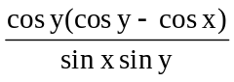.
34. Given that y = x sin 2x, prove that x² - 2x + 2y + 4x²y = 0.
35. Given that y = 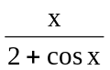, find the values of when x = 0, 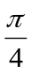 and π.
36. If y = 3x sin 3x + cos3x, show that x + 9xy = 2.
37. A particle is moving In a straight line and its distance s from a fixed point of the line .after t s is given by s = sin2t.
Find its velocity and acceleration at this time and prove that its acceleration is always numerically 4 times its distance from the fixed point and directed towards the point. What is Its velocity and acceleration at times 0, , 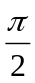, π, 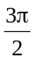, 2π s? Make a diagrammatic sketch of the motion. (Such a motion is called Simple Harmonic Motion).
38. If y = P cos2x + Q sin 2x, where P and Q are constants, prove that + 4y = 0. if y = 1 when x = 0 and = 2 when x = find the values of P and Q.
39. If y = 2 cosx + 3 sin x – cos2x, prove that + y = 3cos2x.
40. If y = sin x + 3 cos2x, solve the equation = 0 in the range 0 to 2π and hence find the maximum and minimum values of y in that range.
41. If y = tan 2x, prove that = 2 (1 + y²).
42. If y = 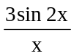, prove that x + 2 + 3xy = 0.
43. Prove that the maximum value of cosx – sin x 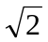.
44. If y = sin x, prove that 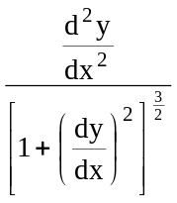 = 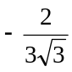 when x = .
45. If r = 1 – cos θ, use the result of No 33 in Ex. 10.5 to prove that 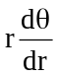 = cot 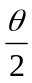.

SUMMARY
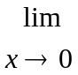 = 1 (x in radians).
Note: The following are only true if x is in radians.
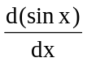 = cosx; = - sin x;
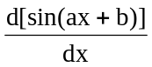 = a cos(ax + b); 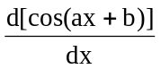 = - a sin (ax + b)
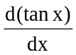 = sec² x; 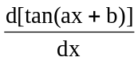 = a sec² (ax + b);

